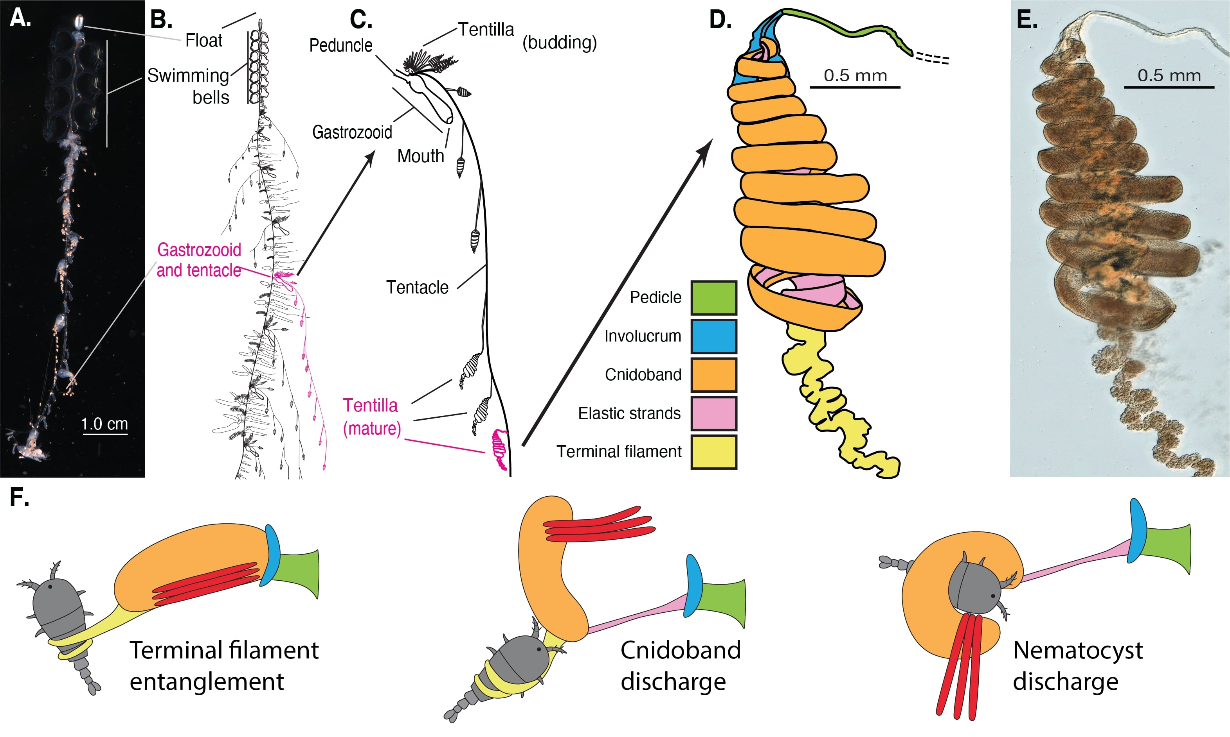

Figure 1. Siphonophore anatomy. A - *Nanomia* sp. siphonophore colony (photo by Catriona Munro). B, C - Illustration of a *Nanomia* colony, gastrozooid, and tentacle closeup (by Freya Goetz). D - *Nanomia* sp. Tentillum illustration and main parts. E - Differential interference contrast micrograph of the tentillum illustrated in D (Specimen: YPM IZ 106704). Figure reproduced from Damian-Serrano et al. 2021 with permission. F. Action strip showing the behavior of tentilla during prey capture, illustrated by Riley Thompson.

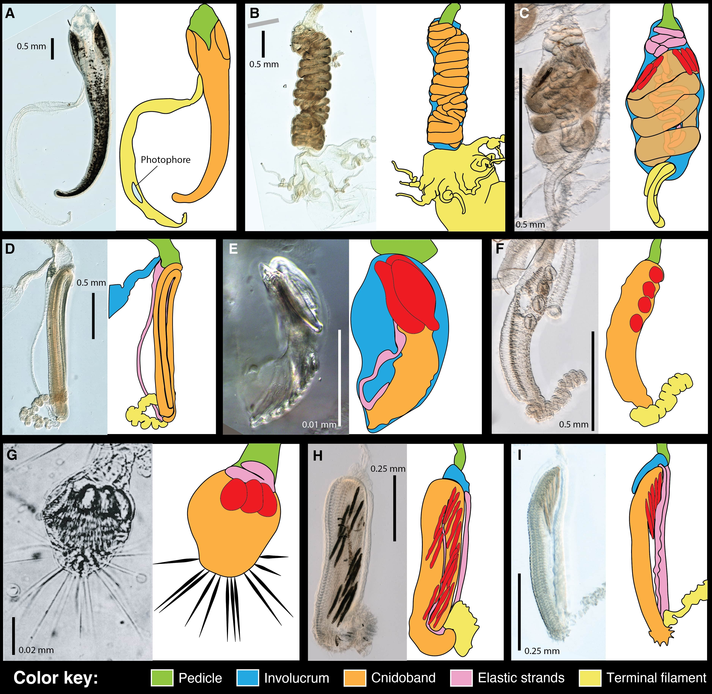

Figure 2. Tentillum diversity. The illustrations delineate the pedicle, involucrum, cnidoband, elastic strands, and terminal structures. Heteroneme nematocysts (stenoteles in C,E,F,G and mastigophores in H,I) are only depicted for some species. A - *Erenna laciniata* bears giant tentilla with a flicking bioluminescent lure, 10x. B - *Lychnagalma utricularia* has a large convoluted cnidoband and unique buoyant medusa-shaped vesicle, 10x. C - *Agalma elegans* has dual terminal filaments and ampulla, 10x. D - *Resomia ornicephala* presents a zig-zag cnidoband and flap-shaped fluorescent involucrum, 10x. E - *Frillagalma vityazi* has a minute encapsulated cnidoband with just three stenoteles, 20x. F - *Bargmannia amoena* presents a simple tentillum with massive round stenoteles, 10x. G - *Cordagalma* sp. has a greatly reduced tentillum with long terminal cnidocils (nematocyst-triggering sensory cilia), reproduced from Carré 1968. H - *Lilyopsis fluoracantha* tentilla bear a pleated cnidoband flanked by long mastigophores, 20x. I - *Abylopsis tetragona* exemplifies a typical calycophorans tentillum with desmonemes clustered at the distal end of the cnidoband, 20x.

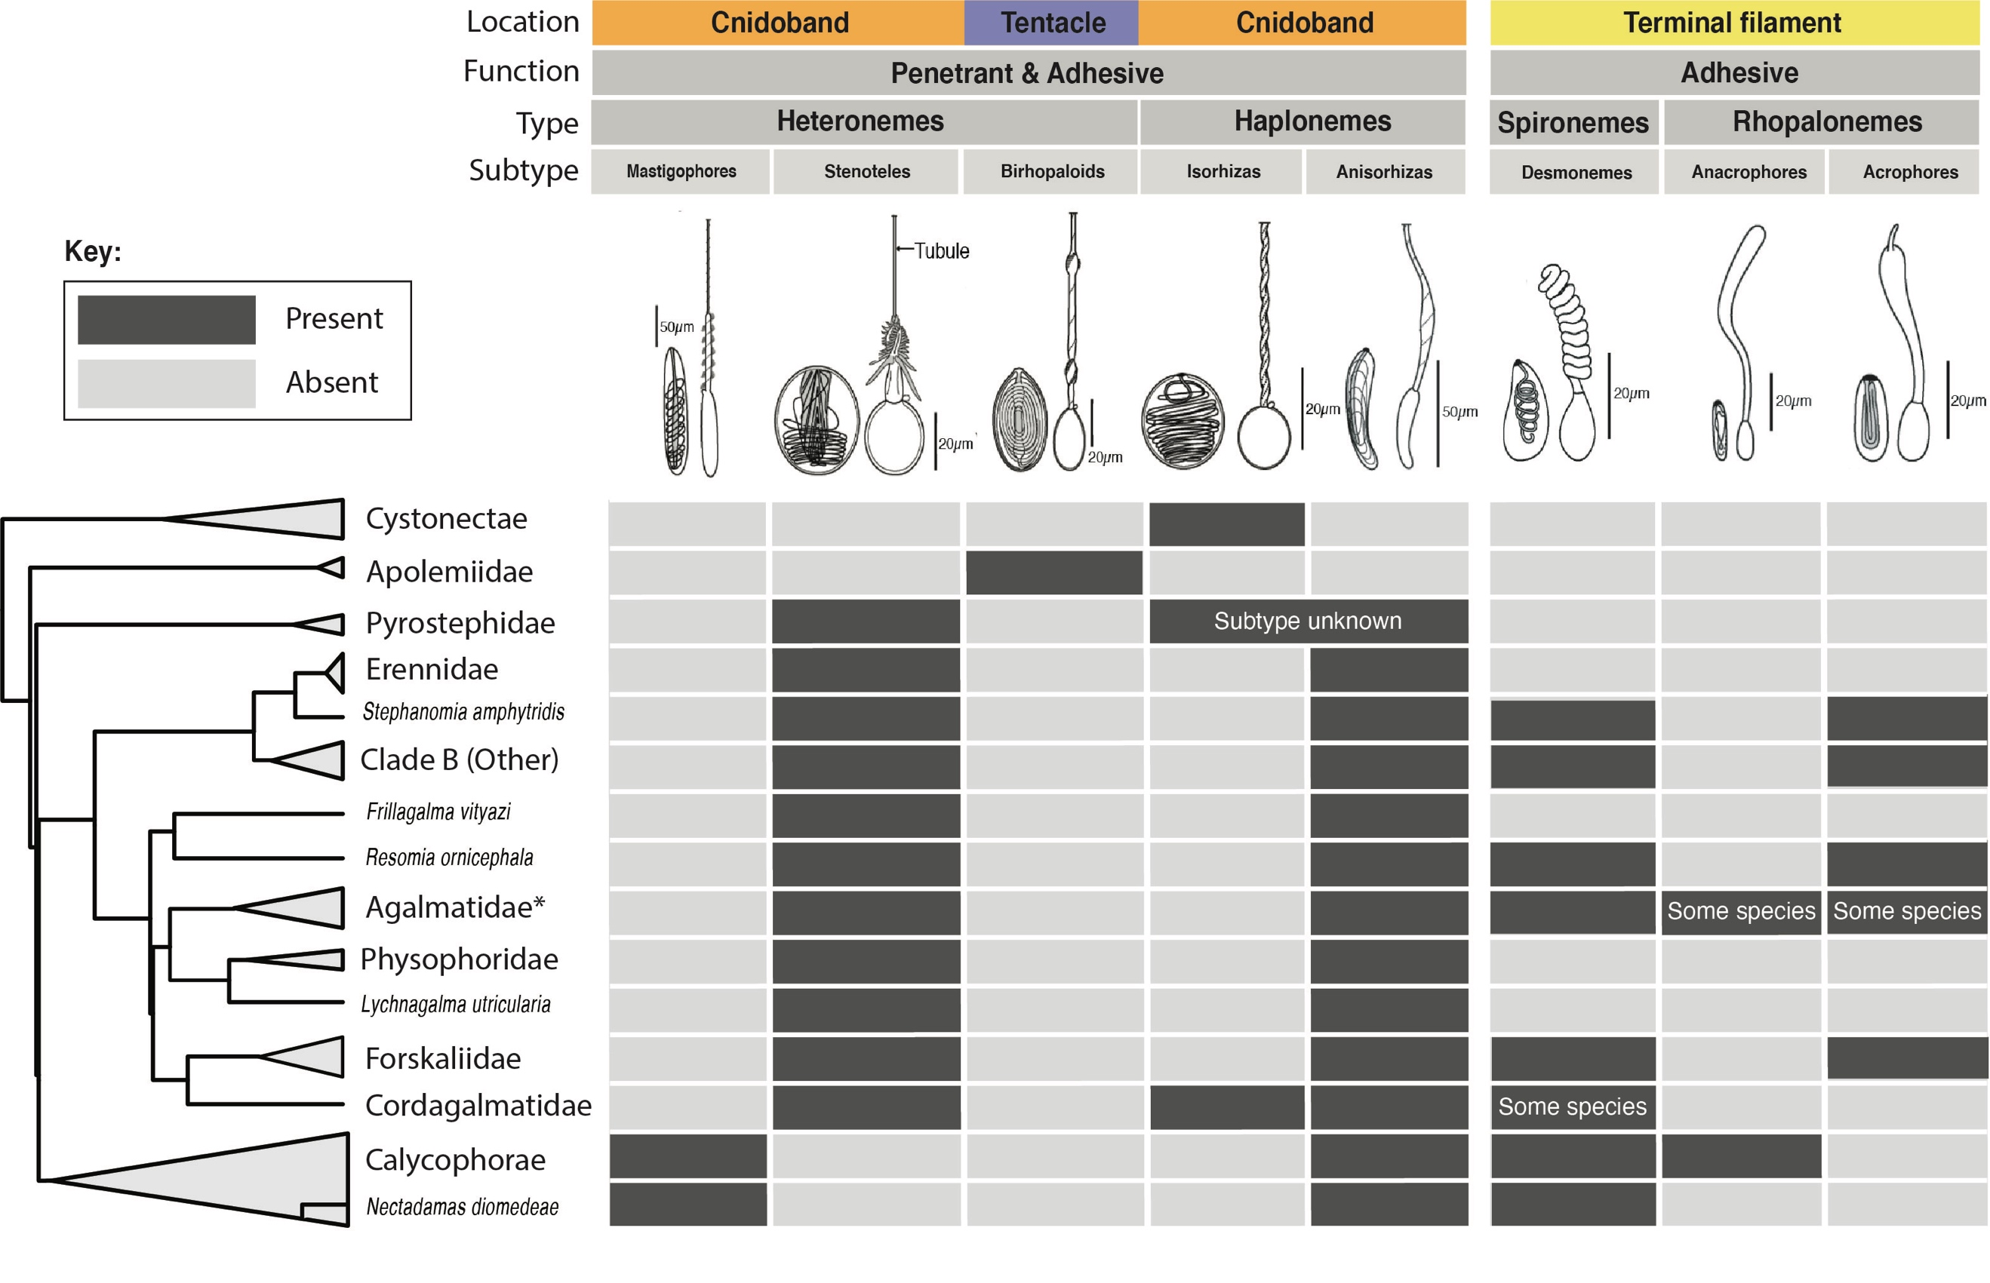

Figure 3. Phylogenetic distribution of nematocyst types, subtypes, functions, and locations in the tentacle across the major siphonophore clades. Illustrations reproduced with permission from Mapstone (2014). Undischarged capsules to the left, discharged to the right. Agalmatidae\* here refers only to the genera *Agalma*, *Athorybia*, *Halistemma*, and *Nanomia*.

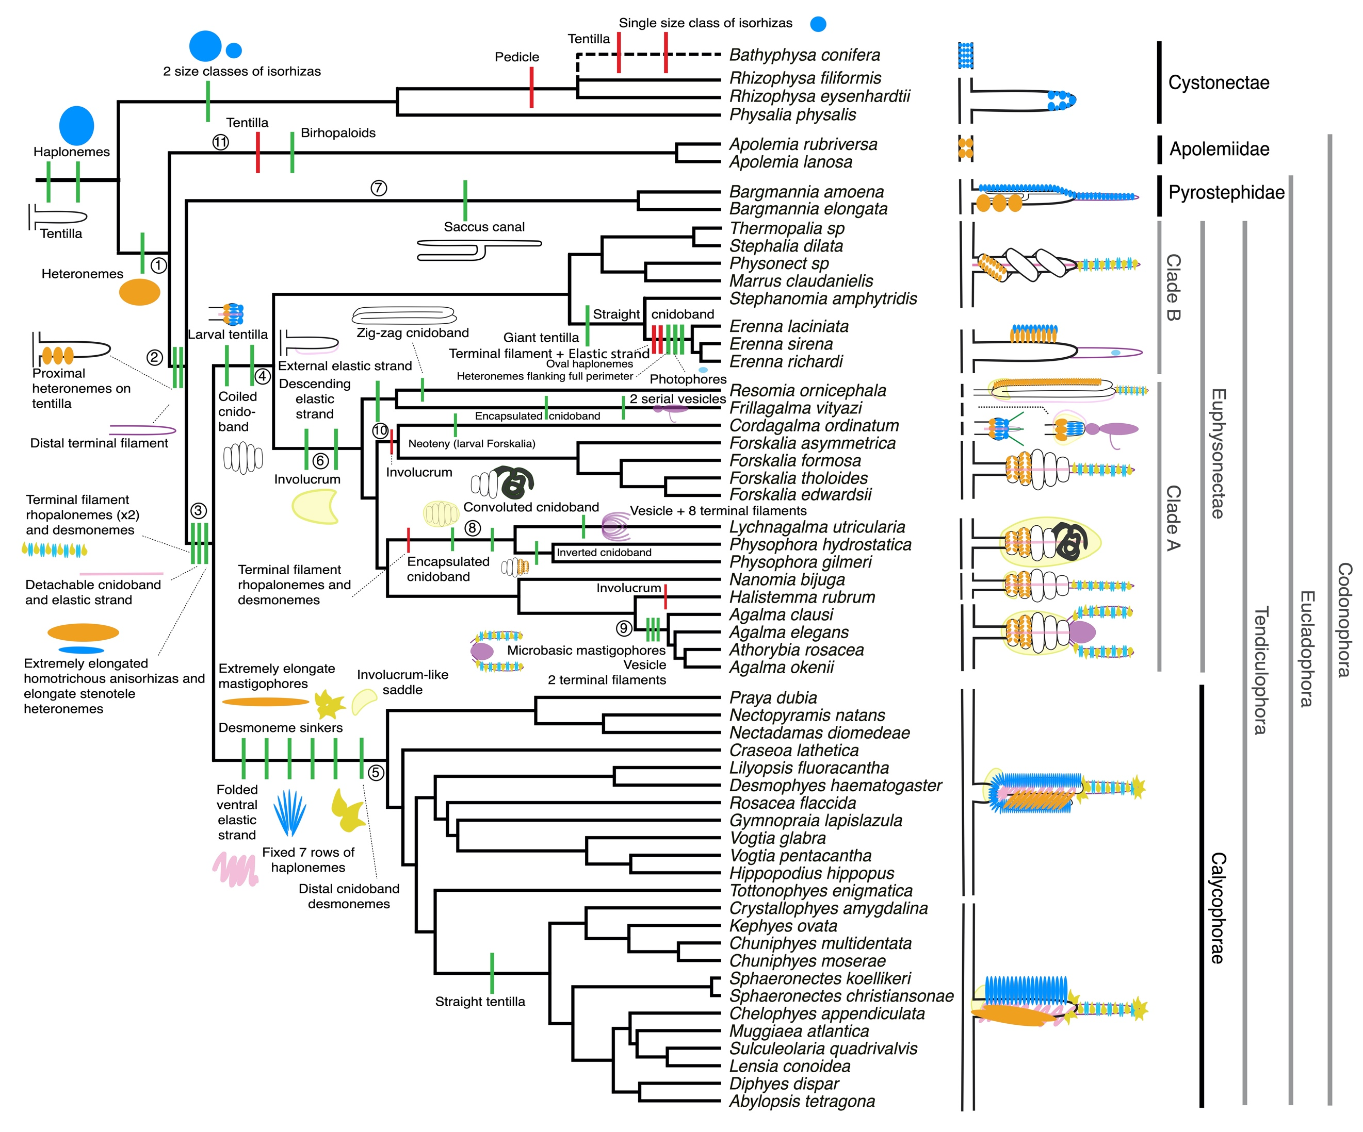

Figure 4. Siphonophore cladogram with the main categorical character gains (green) and losses (red) mapped. Some branch lengths were modified from the Bayesian chronogram to improve readability. The main visually distinguishable tentillum types are sketched next to the species that bear them, showing the location and arrangement of the main characters. In large, complex-shaped euphysonect tentilla, haplonemes were omitted for simplification. The hypothesized phylogenetic placement of the rhizophysid *Bathyphysa conifera*, for which no molecular data are yet available, was added manually (dashed line). Some branches have been numbered 1-11 to facilitate their reference in the text.

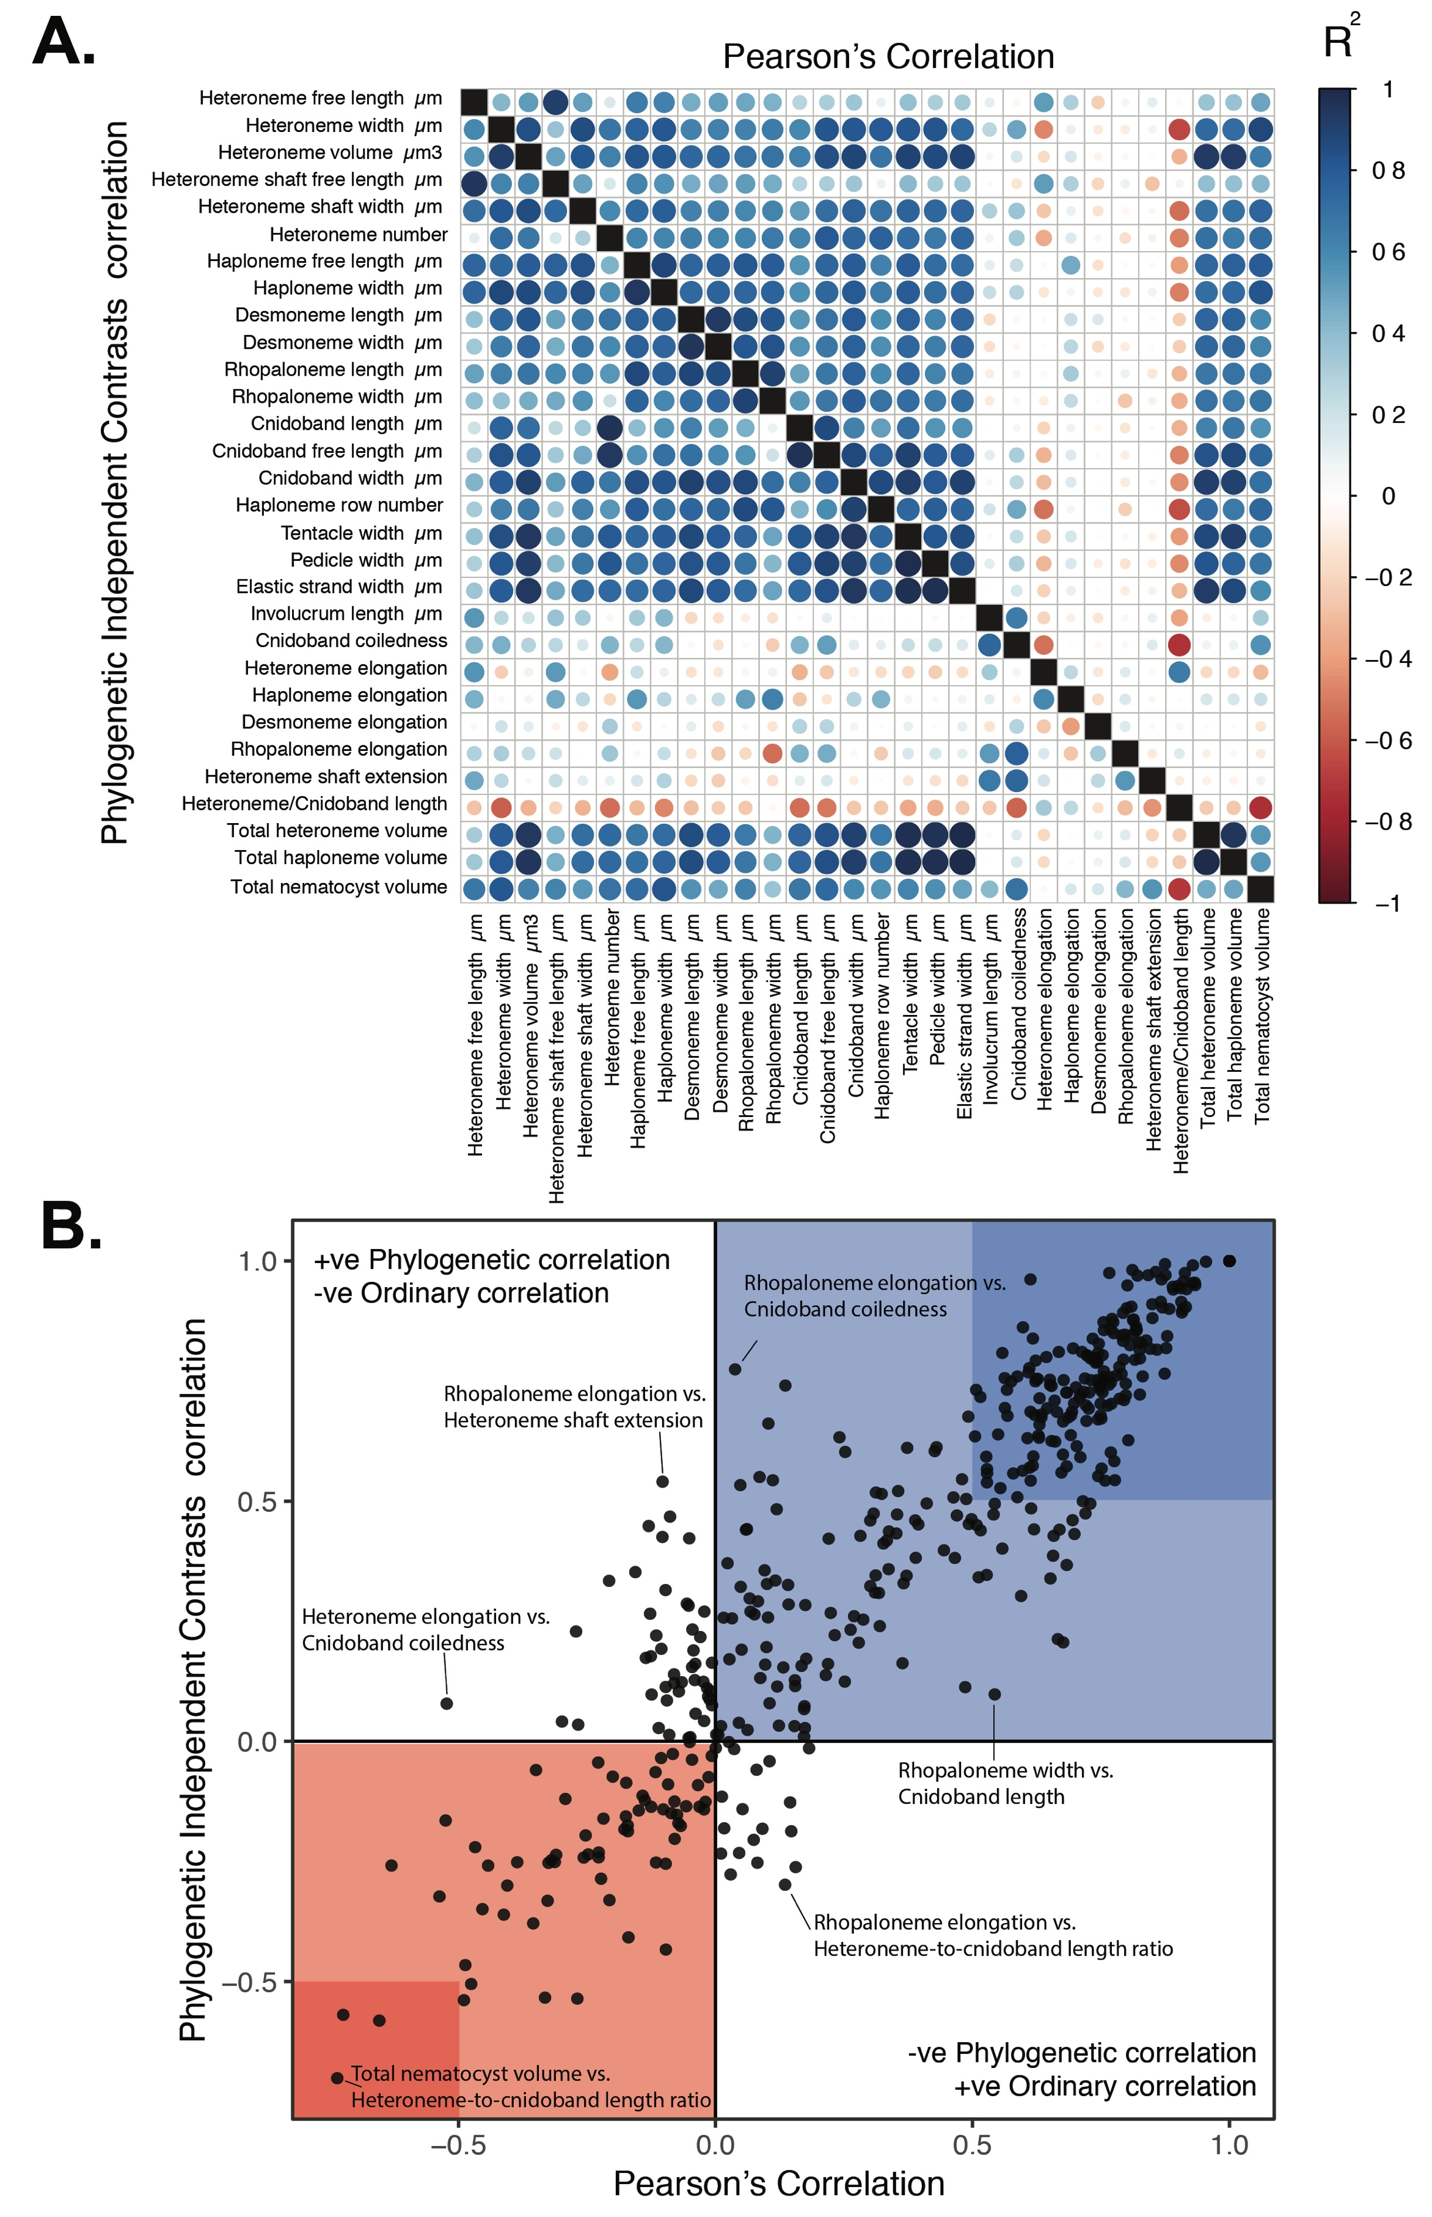

Figure 5. A. Correlogram showing strength of ordinary (upper triangle) and phylogenetic (lower triangle) correlations between characters. Both size and color of the circles indicate the strength of the correlation (R2). B. Scatterplot of phylogenetic correlation against ordinary correlation showing a strong linear relationship (R2 = 0.92, 95% confidence between 0.90 and 0.93). Light red and blue boxes indicate congruent negative and positive correlations respectively. Darker red and blue boxes indicate strong (<-0.5 or >0.5) negative and positive correlation coefficients respectively.

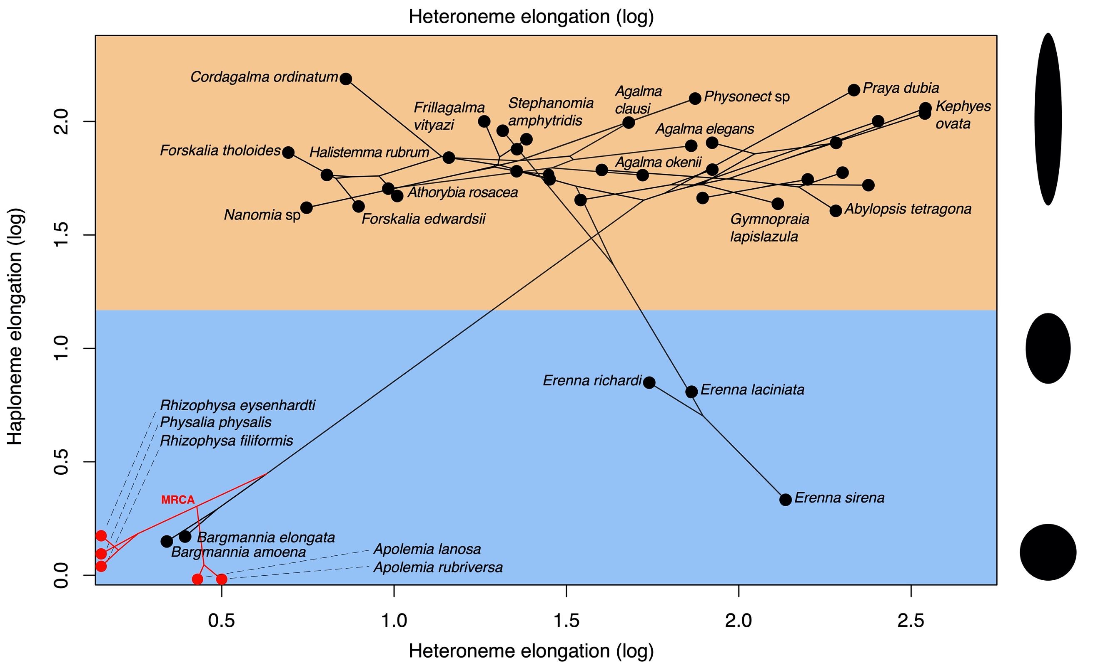

Figure 6. Phylomorphospace showing haploneme and heteroneme elongation (log scaled). Orange area delimits rod-shaped haplonemes, the blue area covers oval and round-shaped haplonemes. Smaller dots and lines represent phylogenetic relationships and ancestral states of internal nodes under BM. Species nodes in red lack either haplonemes or heteronemes, and their values are projected onto the axis of the nematocyst type they bear. Cystonects have no tentacle heteronemes and are projected onto the haploneme axis. Apolemiids have no tentacle haplonemes and are projected onto the heteroneme axis. Silhouettes on the right side represent haploneme shapes along the y axis.

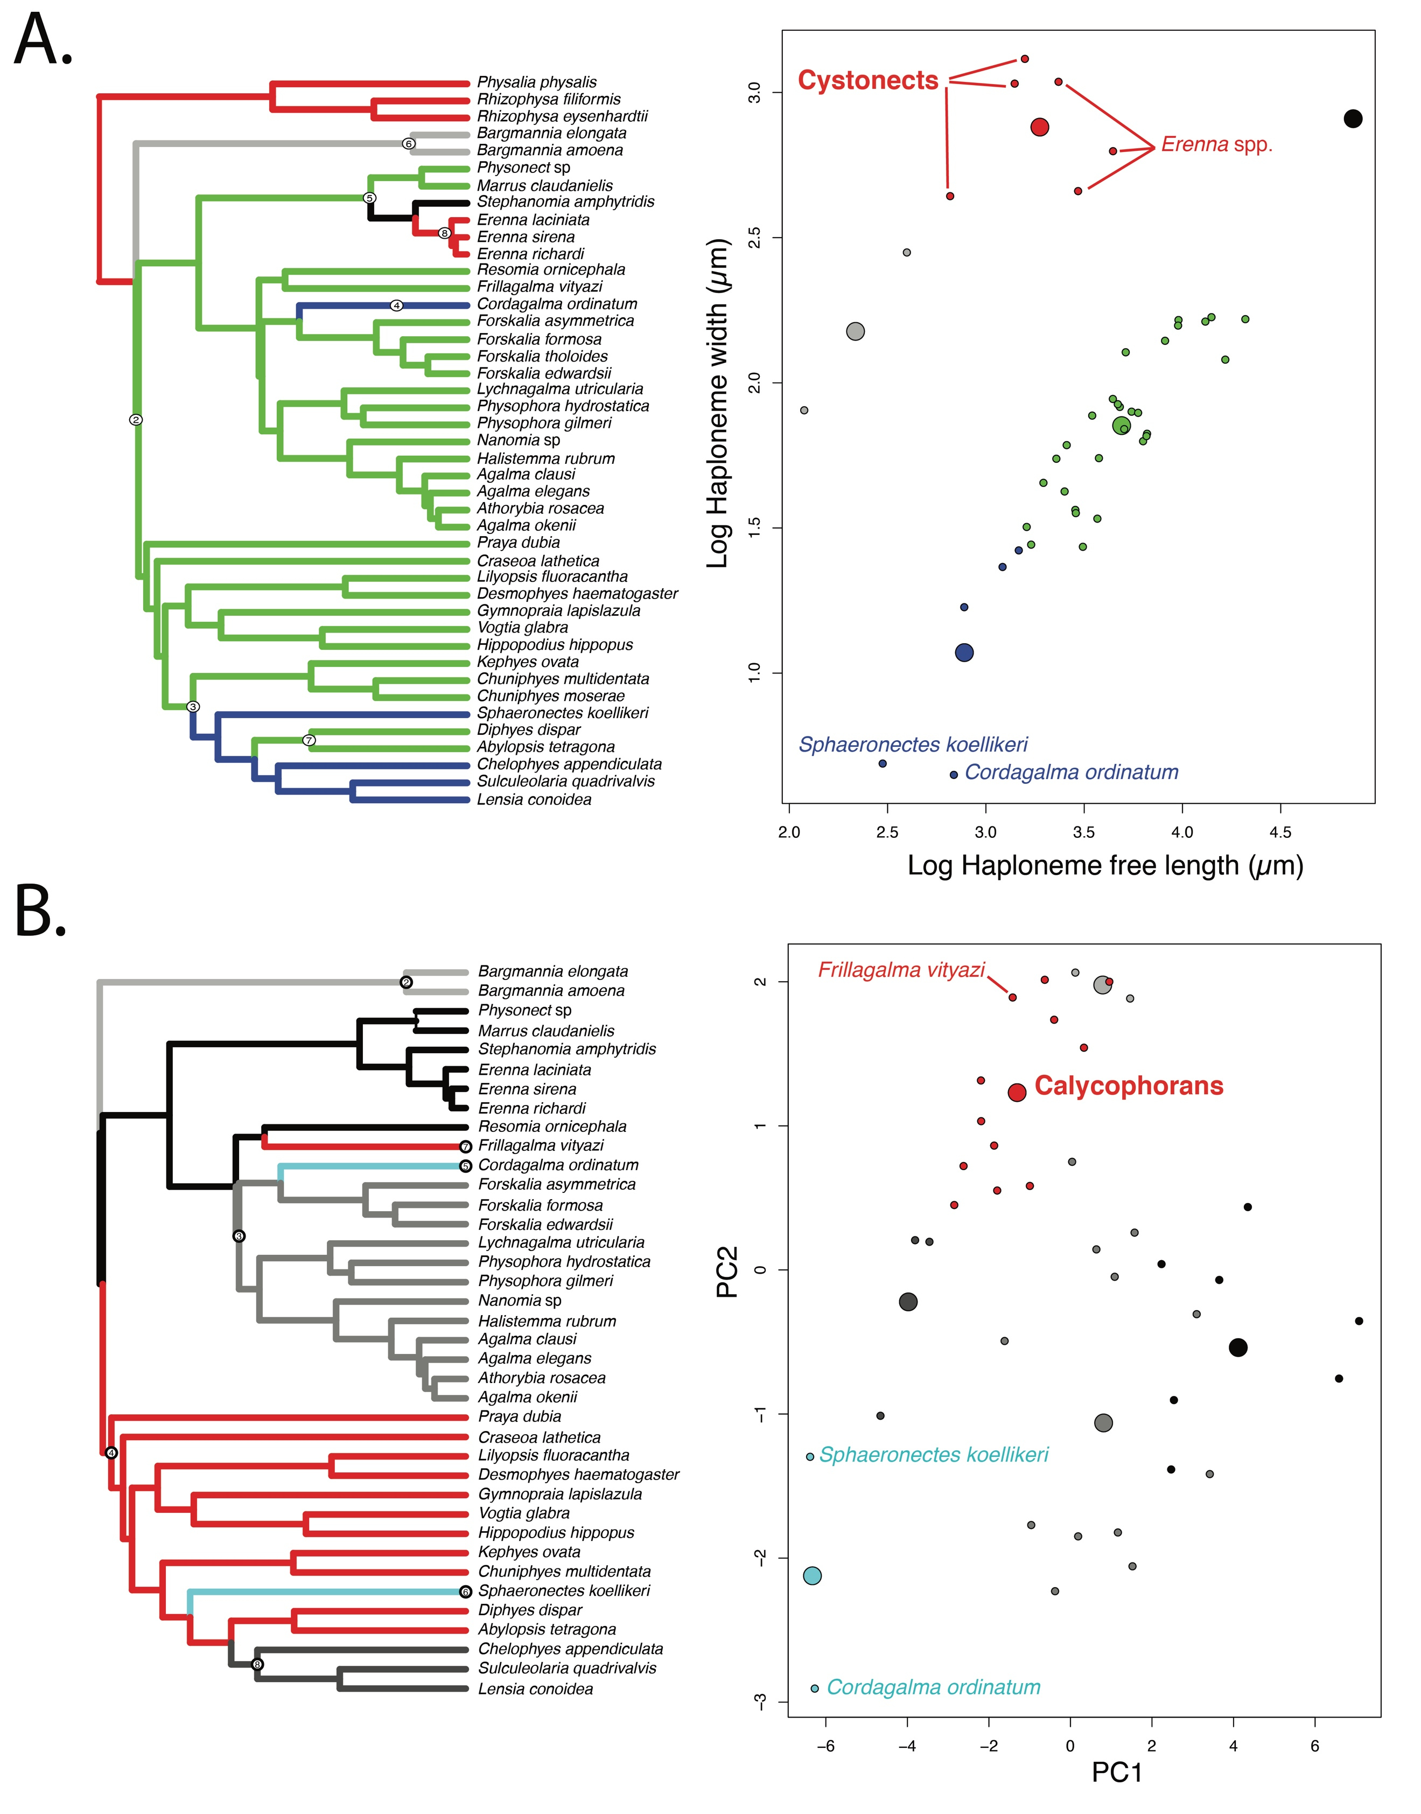

Figure 7. SURFACE plots showing convergent evolutionary regimes modelled under OU for (A) haploneme nematocyst length & width, and (B) for PC1 & PC2 of all continuous characters with the exception of terminal filament nematocysts, and removing taxa with inapplicable character states. Node numbers on the tree label different regimes, regimes of the same color are identified as convergent. Small circles on the scatterplots indicate species values, large circles indicate the average position of the OU optima (*theta*) for a given combination of convergent regimes.

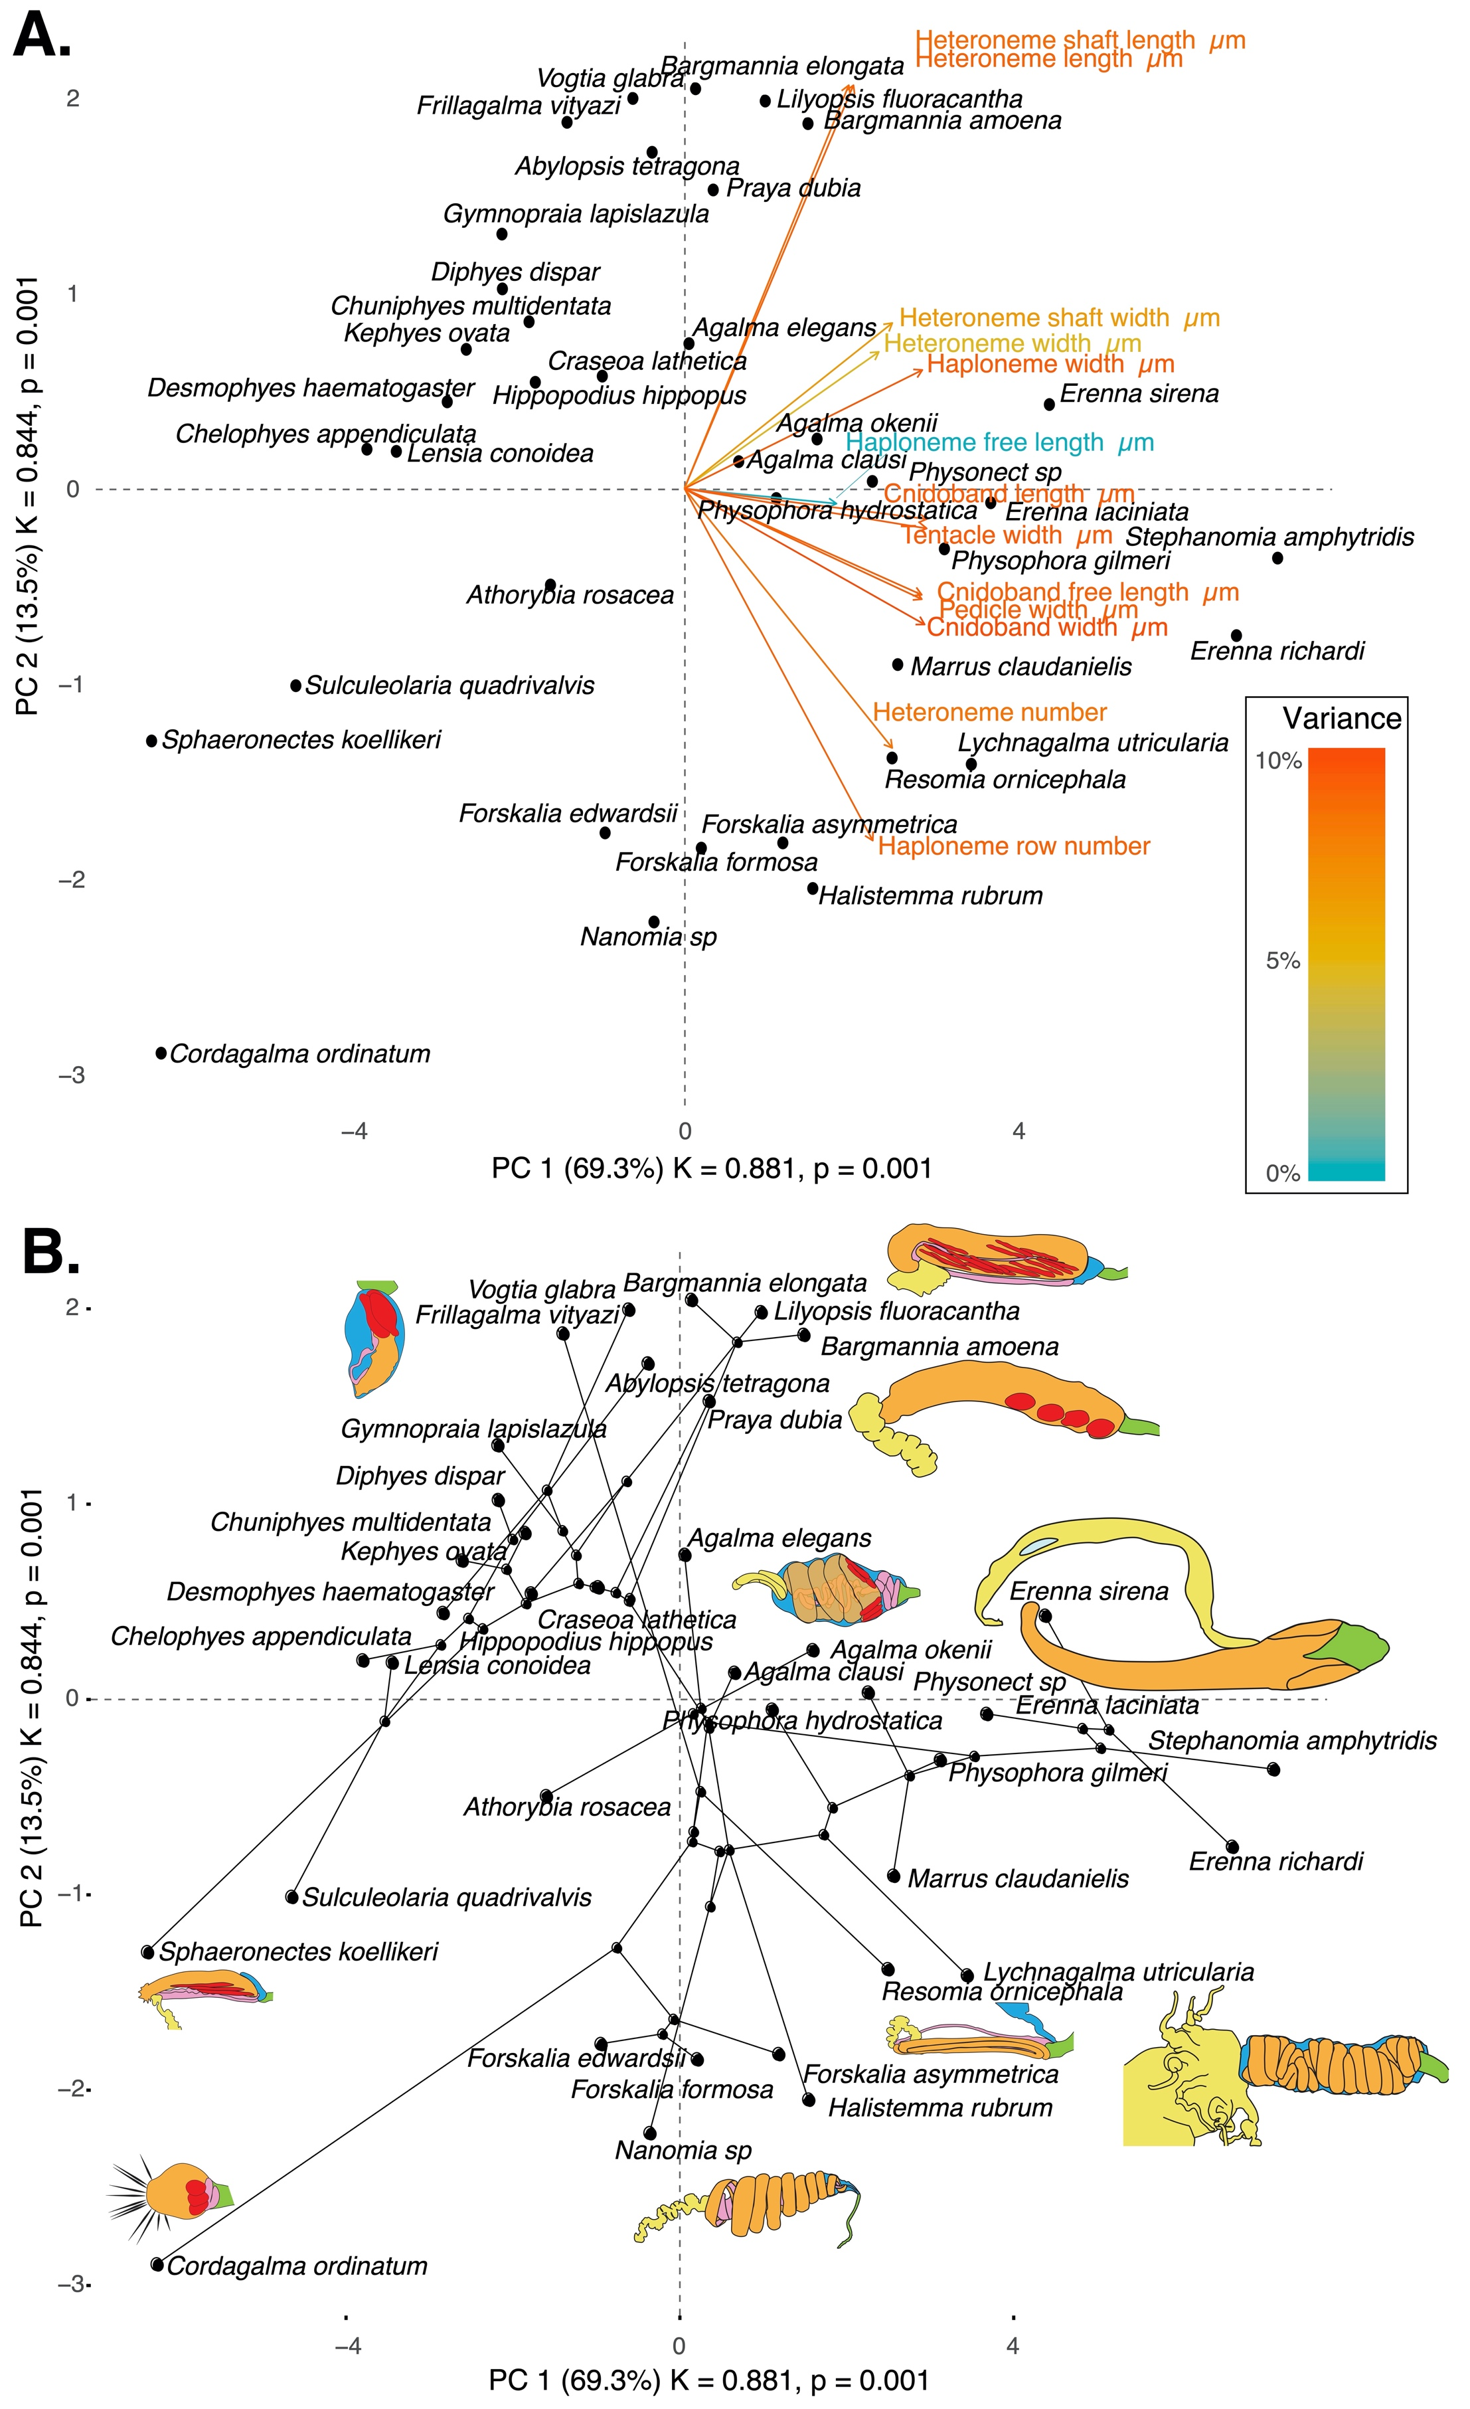

Figure 8. PCA of the simple-measurement continuous characters principal components, excluding ratios and composite characters. A. Variance explained by each variable in the PC1-PC2 plane. Axis labels include the phylogenetic signal (K) for each component and p-value. B. Phylogenetic relationships between the species points and reconstructed ancestors distributed in that same space.

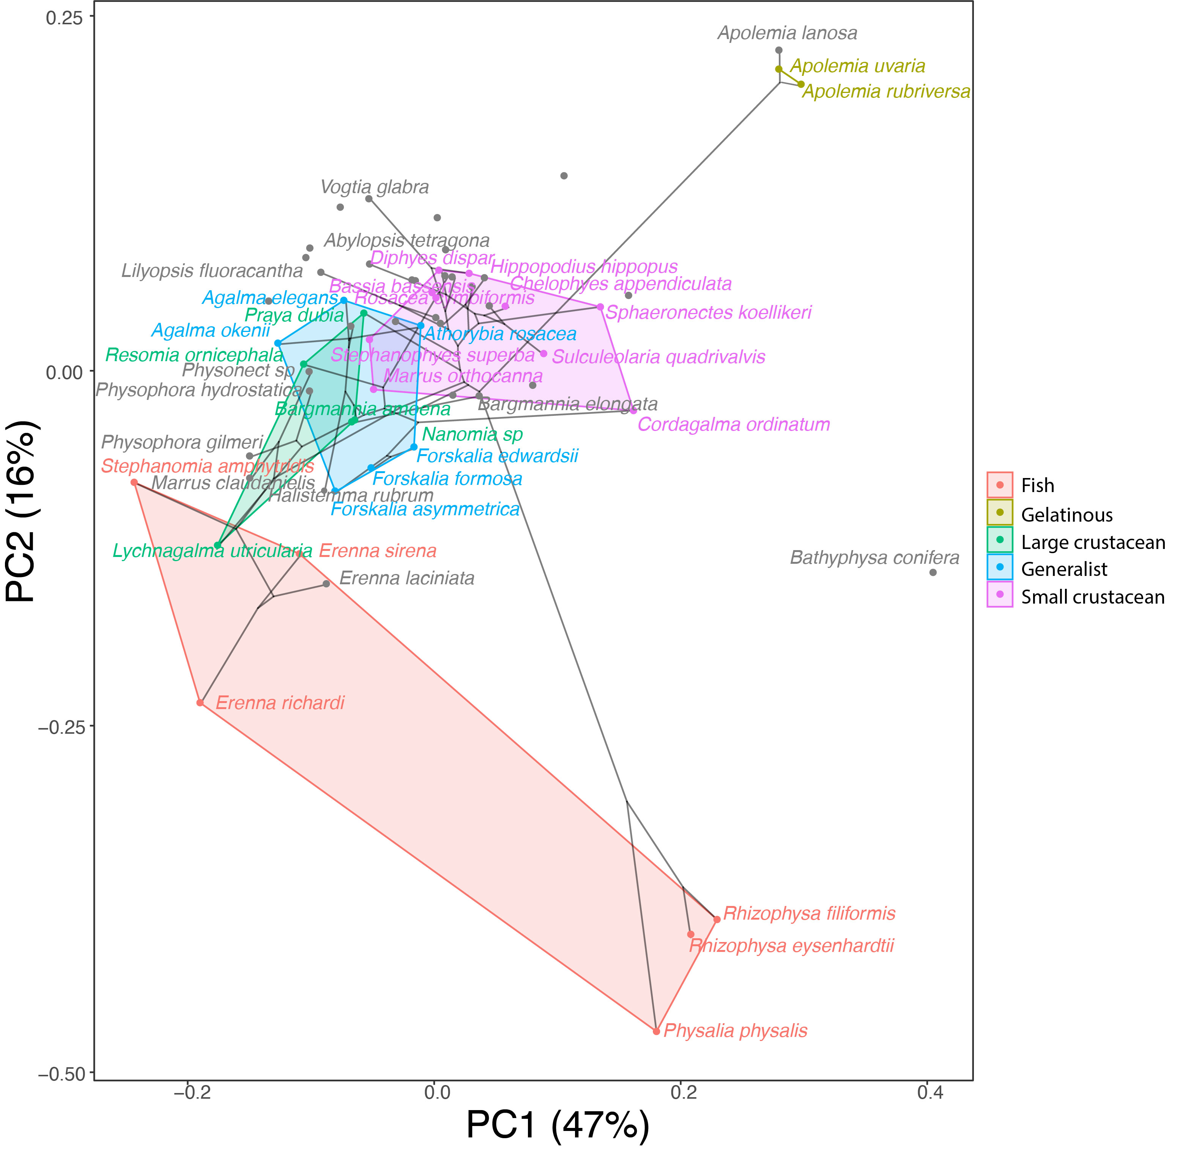

Figure 9. Phylomorphospace showing PC1 and PC2 from a PCA of continuous morphological characters with inapplicable states transformed to zeroes, overlapped with polygons conservatively defining the space occupied by each feeding guild. Lines between species coordinates show the phylogenetic relationships between them. Grey points indicate species with no feeding guild information.

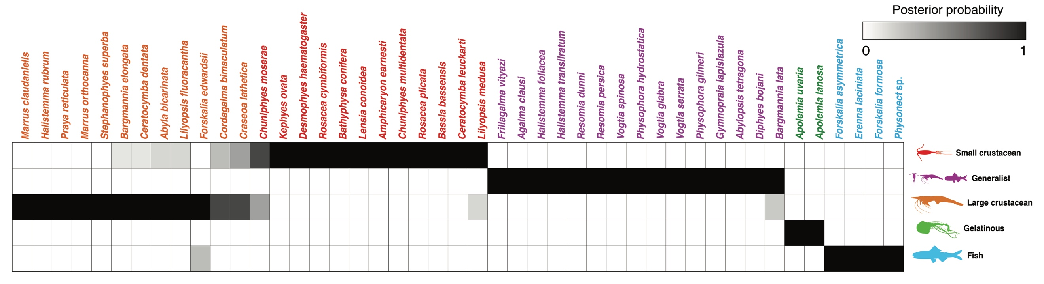

Figure 10. Hypothetical feeding guilds for siphonophore species predicted by a 6 PCA DAPC. Cell darkness indicates the posterior probability of belonging to each guild. The training dataset was transformed so inapplicable states are computed as zeroes. Species are sorted and colored according to their predicted feeding guild.